Map of Houston

1. Harris county

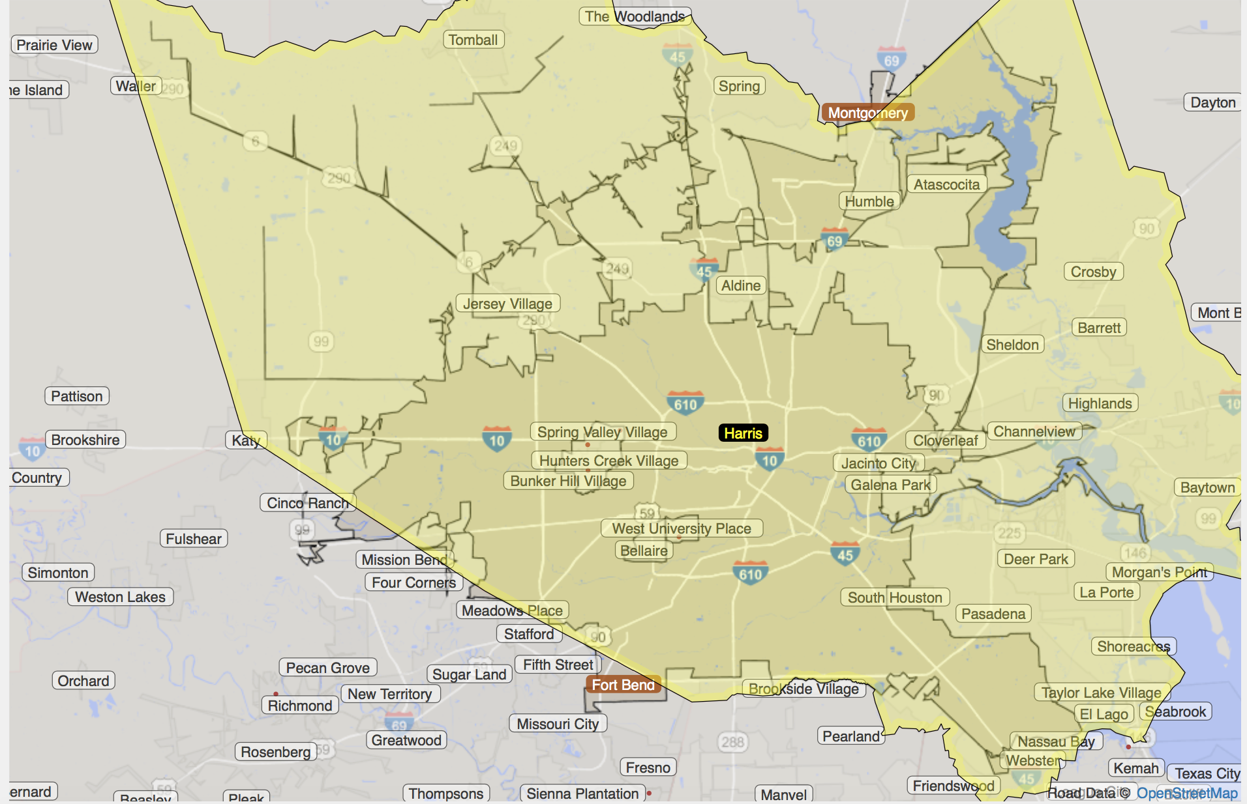

1. Houston city
2. Houston area (Metro Area)

<http://statisticalatlas.com/metro-area/Texas/Houston/Overview>

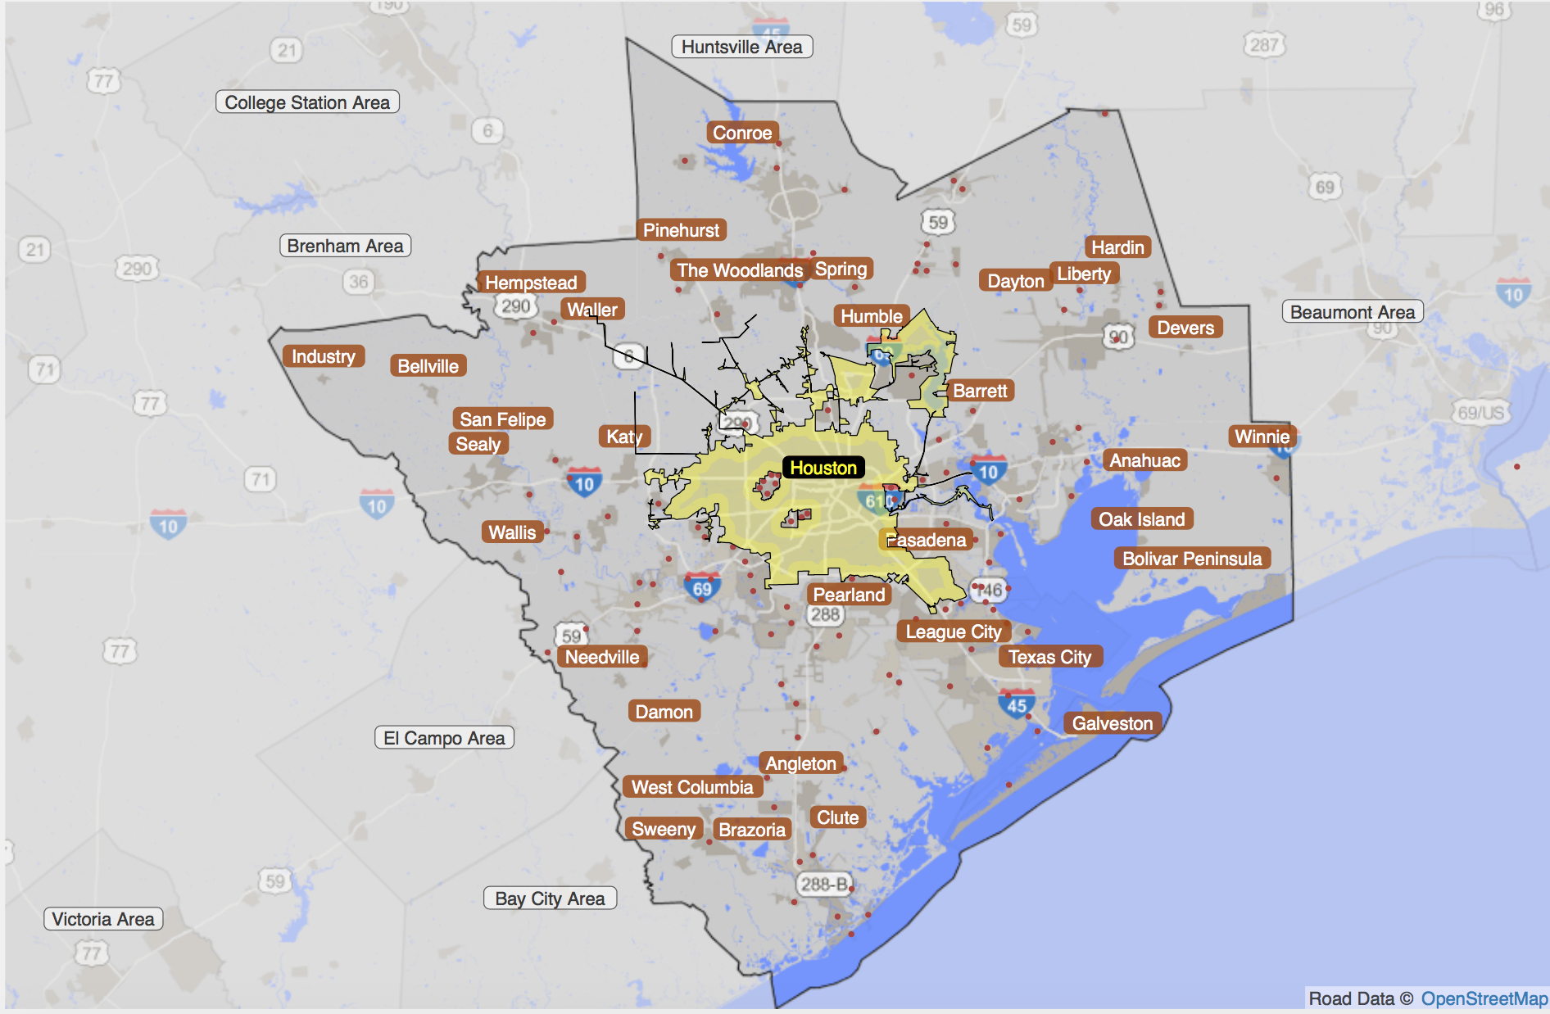

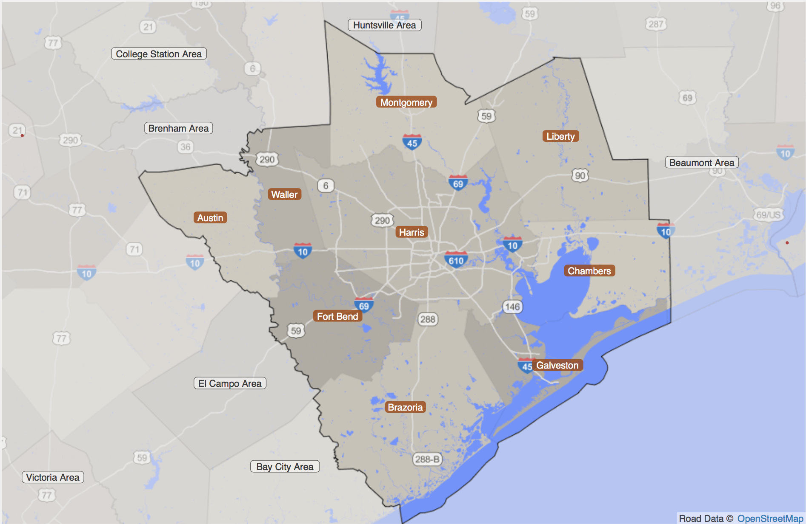

The total population in Houston area is 6,063,540, and there are 2,068,518 households.

Houston area (Metro area) has 9 counties, and they are:

Montgomery (339), Liberty (291), Chambers (071), Galveston (167), Harris (201), Waller (473), Austin (015), Fort Bend (157), Brazoria (039)

<https://factfinder.census.gov/faces/nav/jsf/pages/searchresults.xhtml?refresh=t>

Marginal distribution available in County level:

1. Age by sex
2. Marital status
3. Education attainment
4. Individual income in the past 12 month
5. Commuting characteristics by sex: means of transportation to work; place of work; time leaving home to go to work; travel time to work; vehicle available;

Map census tract to puma, filename: “2010_Census_Tract_to_2010_PUMA.txt”

We will get PUMA which is Houston metro area:

'05000' '04801' '04802' '04803' '04400' '04901' '04902' '04903' '04904'

'04905' '04701' '04702' '04601' '04602' '04603' '04604' '04605' '04606'

'04607' '04608' '04609' '04610' '04611' '04612' '04613' '04614' '04615'

'04616' '04617' '04618' '04619' '04620' '04621' '04622' '04623' '04624'

'04625' '04626' '04627' '04628' '04629' '04630' '04631' '04632' '04633'

'04634' '04635' '04636' '04637' '04638' '04501' '04502' '04503' '04504'

All related variables in PUMS person data:

1. SERIALNO: Housing unit/GQ person serial number
2. SPORDER: Person number
3. PUMA
4. AGEP: AGE
5. COW: Class of worker
6. ESR: Employment status recode
7. JWMNP: Travel time to work
8. JWTR: Means of transportation to work
9. MAR: Marital status
10. RELP: Relationship
11. SEX
12. SCHL: Education attainment
13. ESR: Employment status
14. PINCP: Total person’s income
15. ADJINC: Adjustment factor for income and earnings dollar amounts

Land Use:

Aggregate data for population